La Mesa Llena De Gente
(The Crowded Table)

Desayuno (Breakfast)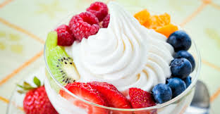
$2.75 Huevos con tocino u salchicha
(Eggs with bacon or sausage)
$1.50 Salchicha bizcocho
(Sausage biscuit)
$1.75 Yogur con fruta
(Yogurt with fruit)

Almuerzo (Lunch)
Todas contener la lado 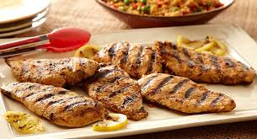
(All include a side)
$3.99 Hamburguesa con u sin queso
(Hamburger with or without queso)
$2.99 Jamón torta
(Ham sandwich)
$3.25 Pollo a la parrilla
(Grilled chicken)
Lados (Sides): Papas fritas, Fruta, Vegetales
(French fries, Fruit, Vegetables)

Cena (Dinner)
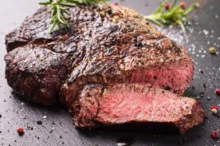Todas contener la lado
(All include a side)
$2.99 Bistec con sal y pimiento
(Steak with salt and pepper)
$3.25 Pescado con mantequilla
(Fish with butter)
$3.75 Pollo sopa
(Chicken Soup)
Lados (Sides): Vegetales, Fruta, Arrzo, Frijoles, Elote
(Vegetables, Fruit, Rice, Beans, Corn)

Postre (Dessert)
$1.25 Dulces
(Candy/ Sweets)
$1.50 Galletas
(Cookies)
$2.00 Helado con Cereza http://www.google.com/imgres?imgurl=http://morellisicecream.com/wp-content/uploads/2014/05/MIC-3scoops-banner.png&imgrefurl=http://morellisicecream.com/&h=269&w=550&tbnid=xREqpSedvSR0DM:&docid=UMVbqzCGq8ORKM&ei=HJQzVu7lM4H9mAGQvYK4Bw&tbm=isch&ved=0CDMQMygCMAJqFQoTCO7jlLbI6sgCFYE-JgodkJ4Adw
(Ice cream with cherry)

Menú Infantil (Kids Menu)
$2.50 Pavo u jamón torta
(Turkey or ham sandwich)
$2.75 Pollo torta
(Chicken sandwich)
$2.00 Salchicha
(Sausage)
$2.99 Jr. tocino hamburguesa con queso
(Jr. bacon hamburger with cheese)
$1.99 Queso a la parrilla
(Grilled Cheese)

Aperetivoes (Appetizers)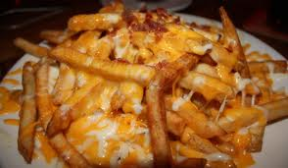
$3.99 Papas fritas con queso
(French Fries with cheese)
$2.25 Fruta u vegetales
(Fruit or vegetables)
$3.00 Aros de cebolla
(Onion rings)

Bebida (Drinks)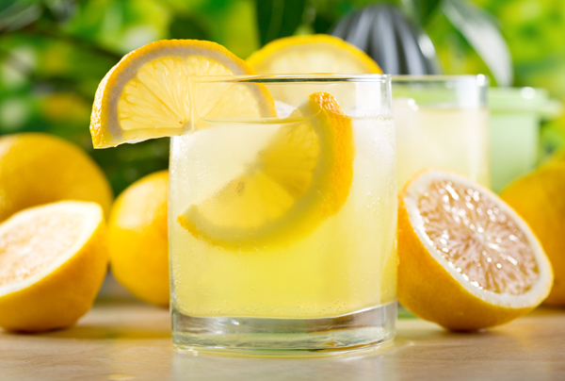
$1.50 Aqua
(Water)
$2.00 Café
(Coffee)
$2.00 Jugo- Fruta, Manzana, Naranja, uva
(Juice- Fruit, Apple, Orange, Grape)
$1.99 Leche
(Milk)
$2.00 Limonada, Fresa Limonada
(Lemonade, Strawberry Lemonade)
$2.25 Té Con Azúcar
(Tea with sugar)
$2.00 Refresco - Coke, Sprite, Dr. Pepper, Fanta, Sierra Mist
(Soda)

